Accelerating photo-stability evaluation of perovskite films through intelligent spectral learning-based early diagnosis
Ziyi Liu¹, Jiyun Zhang^{2,3}, Gaofeng Rao¹, Zijian Peng², Yixing Huang⁴, Simon Arnold^{2,3}, Bowen Liu¹, Can Deng¹, Chen Li¹, Heng Li¹, Hanxiang Zhi¹, Zhi Zhang^{5,6}, Wenke Zhou^{5,6}, Jens Hauch^{2,3}, Chaoyi Yan¹, Christoph J. Brabec^{2,3*}, Yicheng Zhao^{1*}

¹ University of Electronic Science and Technology of China (UESTC), State Key Laboratory
of Electronic Thin Films and Integrated Devices, School of Integrated Circuit Science and Engineering, Chengdu 611731, P. R. China
² Helmholtz-Institute Erlangen-Nürnberg (HI ERN), Erlangen 91058, Germany
³ Friedrich-Alexander-University Erlangen-Nuremberg (FAU), Department of Material Science, Materials for Electronics and Energy Technology (i-MEET), Erlangen 91058, Germany
⁴ Friedrich-Alexander-University Erlangen-Nuremberg (FAU), Department of Radiation Oncology, Erlangen 91058, Germany
⁵ Research Center of Position Engineering, College of National Defense Engineering, Army Engineering University of PLA, Nanjing, 210007, P. R. China
Erlangen, Germany
⁶ State Key Laboratory for Disaster Prevention & Mitigation of Explosion & Impact, Army Engineering University of PLA, Nanjing, 210007, P. R. China

* Correspondence: christoph.brabec@fau.de ; zhaoyicheng@uestc.edu.cn

Abstract
Obtaining highly stable metal-halide perovskites is crucial for the commercialization of perovskite solar cells. However, current methods for evaluating perovskite stability mainly rely on the time-consuming and resource-intensive aging process. Here we demonstrate a spectral learning-based methodology that enables the prediction of perovskite stability by leveraging the features in photoluminescence and absorption spectra of fresh perovskite films. This methodology circumvents the long-term aging process by combining a custom-developed spectral features extraction algorithm and an integrated voting machine learning model. By integrating the early diagnosis program with high-throughput experiments, the prediction accuracy for stable perovskites exceeds 86% in 160 fresh samples. The universality is further examined by another batch of 224 fresh samples fabricated through a different processing condition. Finally, the early diagnosis of perovskite films is successfully translated to enhanced stability in perovskite solar cells. Our work provides a new pathway to accelerate the discovery and development of stable perovskite films.
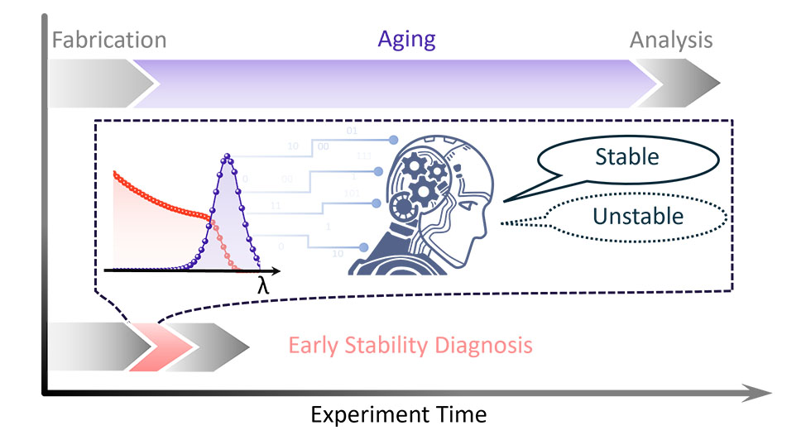
TOC. Intelligent spectral learning for stability early diagnosis of perovskite.

Introduction
Metal-halide perovskites (MHPs) have emerged as highly promising photovoltaic semiconductors, benefiting from their intrinsically high absorption coefficient, long carrier lifetime, exceptional defect tolerance, and simplified solution processing.¹⁻⁵ However, the instability poses a major hurdle to the commercialization of MHPs.⁶⁻⁹ To address this issue, tremendous efforts have been devoted to enhancing the stability of MHPs, such as composition engineering, additive engineering, passivation engineering.¹⁰⁻¹⁶ Among them, composition engineering is widely regarded as the key to achieving high stability of MPHs.¹⁷⁻¹⁸ However, composition engineering typically entails a huge number of experimental trials and subsequent analysis of massive data. Taking the typical ABX₃ structure of three-dimensional MHPs as an example, there are more than 10⁷ kinds of multicomponent combinations between 7 kinds of A-site cations, 2 kinds of B-site cations, and 3 kinds of X-site halides (A, B, and X refer to monovalent cations, divalent metal cations, and halide anions, respectively).¹⁹⁻²³ Thus, exploring such a huge parameter space poses a formidable challenge for stability improvement due to repetitively time-consuming and resource-intensive experiments beyond manpower.
Emerging automatic high-throughput platforms have been introduced to explore the huge compositional library with great precision and efficiency. Even though the tireless robotic high-throughput experiments (HTE) system offers a feasible avenue for addressing this challenge,²⁴⁻²⁸ stability evaluations with a long aging period are still required to extract the longevity of films or devices.^{19-20, 29-30} As presented in Figure 1a, over 90% of the total evaluation time is dominated by long-time aging in each evaluation process. This indicates long-time aging is the throughput-determining step, rather than solution preparation, film fabrication, optical characterization, etc. Therefore, circumventing the long-time aging process is critical to accelerate the development of stable perovskites. Previous reports imply a strong correlation between film inhomogeneity and film instability since inhomogeneity in the fresh perovskite films would accelerate degradation and phase segregation.³¹⁻³³ We reason that the stability of MHPs could be diagnosed at their initial state by analyzing optical spectra, such as photoluminescence (PL) and UV-vis absorption (Abs.) spectra, two of the most common characterizations. They contain abundant information about crystallinity, homogeneity, phase distribution, etc. within perovskite film.³⁴⁻³⁵ Srivastava et al. fed the PL data into machine learning to derive the evolution of optical properties over time.³⁶⁻³⁷ We further expect that combining initial PL/Abs. spectra of pristine perovskite films with machine learning would be a feasible way to diagnose the long-term stability of MHP films.
In this work, we introduce a custom-developed Gaussian-mixture-model (GMM) algorithm coupled with an integrated voting machine learning model (IV-ML) to realize early diagnosis of stability without any aging process. A prediction accuracy exceeding 86% is achieved by the IV-ML machine learning framework. The well-trained framework is also applied to evaluate the stability of other 255 MHP films with different processing conditions. Finally, we demonstrate the application of early diagnosis in perovskite solar cells. The optimum perovskite films enable stable solar cells to retain over 95% of their initial efficiency after 300 hours of continuous working at 65℃ under light illumination.
To establish and train the machine-learning toolkit for early diagnosis of film stability, we first carried out Experiment I. First, 160 perovskite films with different compositions were fabricated through an automatic platform.³⁸ Subsequently, these films are exposed under light illumination over 1700 hours to evaluate their lifetime, as shown in Figure 1a. T₈₀ lifetime is employed to evaluate the stability that represents the time required to decay to 80% of initial absorbance value, considering the decline in absorbance exhibited by perovskite films during the decomposition process. The selection criterion for wavelength is defined as the range between the bandgap of PbI₂ and the bandgap of the perovskite, typically falling in the range of 650-700 nm. We have employed a linear fitting method to determine an estimated T₈₀ value.²⁹ All T₈₀ values are classified and summarized in Figure S3. Note that the composition is quoted from the nominal composition in perovskite-precursor solutions (all sample compositions are summarized in Figure S3).
Distinct characteristics have been observed in the initial PL and Abs. spectra of unstable compositions compared to stable compositions, including broadened PL peaks, multiple PL peaks, and long absorption tails, as demonstrated in Figure 1b-g and Figure S4-S5. These features, observed in unstable samples, are attributed to the inhomogeneity in fresh perovskite films, such as phase impurity, which are closely linked to the stability of perovskite films.³⁹⁻⁴⁰ In case of No.58 sample (with a composition of Cs_{0.3}FA_{0.7}Pb(I_{0.85}Br_{0.15})₃), a subpeak at 762 nm is observed in the PL spectra (Figure 1b), which indicates the presence of phase impurity in No.58 sample. After exposing the sample to over 1700 hours of light illumination, the subpeak undergoes a redshift while its peak intensity decreases by seventy five percent (Figure 1d). Similarly, the absorbance values decrease over time (Figure 1c). In stark contrast to No.58, No.136 sample with a composition of Rb_{0.05}Cs_{0.05}MA_{0.1}FA_{0.8}PbI₃ only shows a single peak in the PL spectra and a steep slope in the Abs. spectra. Both the PL and Abs. spectra demonstrate a minor change after 1700 hours of aging (Figure 1e-g). Generally, incorporating mixed cations can homogenize the distribution of bromide and iodide anions during the crystallization process,⁴¹ while mixed halides can modify the intermediate phase in growing perovskite films.⁴² An over-mixing will result in inhomogeneous films, causing excess defects and strain.^{32-33, 41, 43} We conclude that the initial decomposition mainly occurs in the inhomogeneous regions, then resulting in the degradation of the entire perovskite film, as depicted in Figure 2a.
To elucidate the relationship between spectral features and the stability of perovskite films, it is imperative to quantify the features in PL and Abs. spectra for establishing a machine learning model. Here we quantify 9 features, including peak number, half-width, and parameter difference between multiple peaks in the PL spectrum, slope, and onset wavelength near the edge of absorption spectra in Abs. spectrum (Table S1). However, manual analysis of these features from large amounts of spectra data produced by the HTE platform is challenging. For example, it’s difficult to obtain an accurate function of PL spectra by the least square method, due to a mass of unknown factors in a combination of Gaussian curves, described by univariate Gaussian mixture functions:
$I{\left(λ_{i}\right)=\sum_{k=1}^{K}{A_{k}\exp\left(-\frac{{\left(λ_{i}-μ_{k}\right)}^{2}}{2σ_{k}^{2}}\right)}}^{2}$ (1)
where $K$ is the number of Gaussian components. $A_{k}$, $μ_{k}$ and $σ_{k}$ are intensity, mean, and standard deviation of the k-th Gaussian component, respectively.
Here we introduce an intelligent PL fitting algorithm derived from GMM, termed GMM-PL, which enables efficient quantification of PL features. The workflow of GMM-PL is depicted in Figure 2b. We utilize a modified K-means algorithm to initialize the half-width, intensity, and central position of each peak, and an expectation–maximization (E-M) iteration process is used to obtain these parameters (more details illustrate in Supplemental Note 1).⁴⁴⁻⁴⁶ In addition, the Akaike information criterion , $AIC=2m-2ln(L)$, is utilized in order to accurately determine the optimal number for given spectra ($m$ is the number of model parameters and $L$ is the maximum likelihood value as defined in Supplemental Note 1).⁴⁷ The automatic fitting results for three typical PL spectra are presented in Figure 2c-e, showing an R² score close to 1. The GMM-PL method also demonstrates a remarkable capability in distinguishing single peak and pseudo-single peak with high reproducibility (Figure 2c-d), thanks to the standardized criterion in our algorithm. In addition to intelligent PL analysis, we also develop an algorithm to extract the slope and onset wavelength near the edge of absorption spectra. The basic workflow is as follows: finding the inflection points of the absorbing edge by taking the second derivative, and then fitting it linearly to obtain Abs. features (Supplemental Note 2).
Now there are 9 feature values for each sample derived from their PL/Abs. spectra (Table S1 and Figure S6) and the target is T₈₀ lifetime derived from a series of Abs. spectra over ageing time.²⁸ To establish the relationship between spectral features and T₈₀ lifetime in the training dataset, the Linear Regression, K Nearest Neighbours (KNN), Random Forest Regression, Gradient Boosting (GB), Support Vector Regression (SVR) and XGBoost (XGB) are employed to build regression models. In these regression models, the prediction accuracy is not ideal because of the similarity of spectral characteristics for perovskite films with similar T₈₀ lifetimes (Figures S7 and 12). Therefore, we introduce classification models to predict the stability. The samples are classified into two groups, stable and unstable, using a lifetime threshold of 4000 hours. XGB and GB classification algorithms are used to build the model and present high classification accuracy (Figure S13). Based on the well-established model, we utilize Shapley Additive exPlanations (SHAP) to analyse the contributions of each feature.⁴⁸ The SHAP reveals a great negative impact of peak number and peak-separation degree on T₈₀ lifetime, implying the influence of film homogeneity on film longevity (Figure S8-S10). Similar conclusions are also derived from Pearson correlation analysis (Figure S11).
We notice that the robustness of a single model is not fully satisfactory because the prediction accuracy depends on the splitting of training sets. The random train-test splitting causes the training sets to contain different numbers of samples with T₈₀ lifetime near the threshold (Figure S12 - 13). To improve the robustness of our model, we further develop an integrated voting machine learning (IV-ML) that incorporates an ensemble of 3000 models, distributed between GB and XGB algorithms. Each model within the IV-ML is trained by randomly partitioning the training set and performing binary classification. The final prediction of IV-ML is obtained by consolidating the classification results from each constituent model. The whole machine-learning framework is illustrated in Figure 3a. The classification accuracy of 82% for stable perovskites and 75% for unstable perovskites with a lifetime boundary at 4000 hours (Figure S14). In practical applications, we prefer to make a true-positive value as high as possible for stable perovskites and maintain a relatively low false-negative value for unstable perovskites. Then, we introduce a stability evaluation rule by classifying samples into four stability levels, that is Level-I/II/III/IV. Level-I includes T₈₀ of perovskite films of more than 8000 hours, Level-II includes T₈₀ of perovskite films of more than 4000 hours, Level-III includes perovskite films with vote-for-stable at a rate of 30% in the IV-ML model and the remaining films are classified as Level-IV (Figure S15). The classification accuracy is increased to 86% for stable perovskites, as shown in Figure 3a. As a result, the machine learning framework with the stability evaluation rule allows us to filter out the most unstable samples before aging experiments, which is expected to accelerate the stability evaluation period by one order of magnitude.
To examine the universality of our early diagnosis toolkit, we execute Experiment II by fabricating another batch of 224 perovskite films with a higher precursor concentration (1.4 M versus 1 M in Experiment I). The detailed sample composition information is presented in Table S2. With a higher concentration of perovskite precursors, the film thickness is approx. 550 nm in Experiment II versus 400 nm in Experiment I, as shown in Figure 3b. Only PL and Abs. spectra of these fresh thin films are characterized and the extracted data are then fed into the analysis model for stability evaluation. As a result, only 4 perovskite compositions are predicted to be stable with Level-1, and 178 perovskite compositions are predicted to be unstable with Level-4 (Figure S16). We then randomly selected 32 perovskite compositions to test the accuracy of our prediction (Figure S17-18). The confusion matrix of prediction results with a relatively high accuracy of 81% for unstable perovskite and 64% for stable perovskite is presented in Figure 3b, indicating an eligible prediction accuracy for stable thick films. We also solely attempted IV-ML for these 32 thin films, and the accuracy was improved to 67% for stable perovskite prediction (Figure S19). The limited number of stable samples leads to a significant influence of false counterexample samples on the accuracy of predicting stable samples, though the main cause of the decreased accuracy primarily originates from the variations in thin film fabrication processes. Overall, the above results demonstrate the high robustness of our early diagnosis toolkit.
To verify the effectiveness of the algorithm, the screened films are applied to devices for stability tests. Finally, We examine the stability of perovskite solar cells using our screened thick films. The device architecture is glass/ITO/SnO₂/PCBM/perovskite/PDCBT/PTAA-BCF/Au (Figure 4a), where ITO is indium tin oxide, PCBM is Phenyl-C61-butyric acid methyl ester, PDCBT is Poly[2,2''''-bis[[(2-butyloctyl)oxy]carbonyl]-[2,2':5',2'':5'',2'''-quaterthiophene]-5,5'''-diyl], PTAA and BCF is Poly[bis(4-phenyl)(2,4,6-trimethylphenyl)amine and Tris(pentafluorophenyl)borane, respectively. For stable perovskite films (Rb_{0.05}Cs_{0.05}MA_{0.1}FA_{0.8}PbI₃) in Experiment I, the resulting device retains over 97% of initial PCE after 1100 hours of long-term operation at 65 ℃ (Figure S20). In Experiment II, we select two samples, No. 59 (K_{0.05}Rb_{0.05}EA_{0.05}MA_{0.05}FA_{0.8}PbI₃) and No. 109 (Rb_{0.2}Cs_{0.025}FA_{0.775}PbI₃) to verify device stability, where the stability of No. 59 is better than No. 109. The corresponding two devices show a similar degradation trend of open-circuit voltage (V_{oc}) and short-circuit current (J_{sc}) while a noticeable divergence in the degradation trend of fill factor (FF) (Figure 4c-d). In the first 300 hours of aging, film decomposition mainly occurs at the surface of perovskite films, forming a charge-transfer barrier at the perovskite/HTL interface.⁷ The faster degradation rate of the No. 109 film versus the No. 59 film is highly consistent with the faster decay of FF in the corresponding devices. The main reason is that the inhomogeneous distribution of alkali cation is caused by a higher Rb⁺ concentration of No. 109.^{41, 49} In contrast, No. 59 has almost no longer any decline in performance (Figure 4e, Figure S21), after the initial rapid decay caused by charge accumulation.⁶ The above results indicate a successful early diagnosis of stability in perovskite films.
In conclusion, we have developed a machine learning model enabling early diagnosis for perovskite stability without a long-term aging process. With the early diagnosis, we can accelerate the stability evaluation process by several orders of magnitudes, thus accelerating the development of stable perovskites. The high prediction accuracy achieved owes much to automatic high-throughput experiments, ensuring standard film fabrication and precise film characterization, which is critical in obtaining high-quality big data for machine learning. The combination of high-throughput experiments and machine learning is emerging as a powerful tool capable of elucidating the underlying physical properties behind complex relationships among various experimental parameters and targeting properties.⁵⁰ Besides, it is expected that the prediction accuracy for perovskite stability with contact layer will diminish when we adopt a pre-trained machine learning model by the perovskite stability data without contact layers, considering the structural reconfiguration at the perovskite surface^{43, 51} To establish a robust model capable of predicting perovskite stability with contact layers, it is essential to employ a training dataset of perovskite stability with specific contact layers. We anticipate that our findings to trigger more innovations in applying high-throughput experiments and machine learning to materials science.
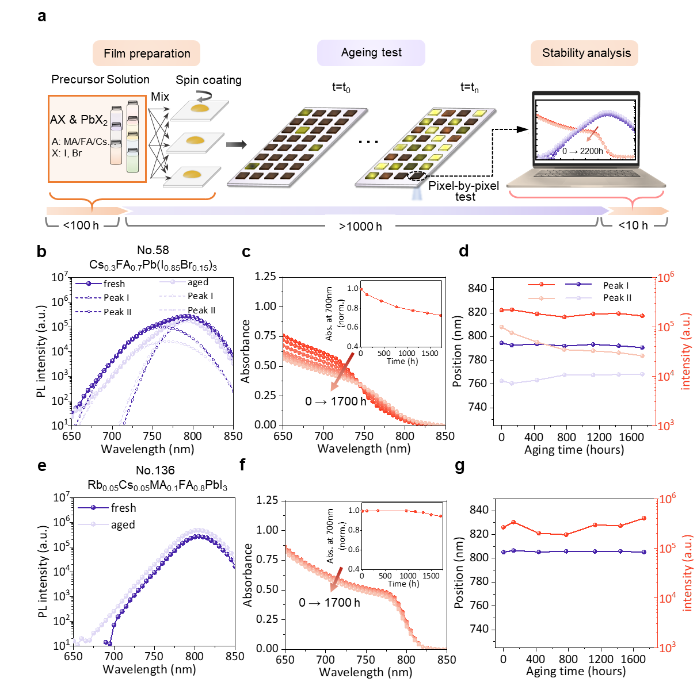
Figure 1. Stability evaluation process and composition-dependent film stability. (a) Time-consumption analysis in the conventional stability evaluation process. (b) and (c) represent PL and Abs. spectra of Cs_{0.3}FA_{0.7}Pb(I_{0.85}Br_{0.15})₃ before and after the aging process, respectively. The inset in (c) represents the variation in absorbance of the perovskite film at 700 nm during a 1700-hour aging process. (e) and (f) represent PL and Abs. spectra of Rb_{0.05}Cs_{0.05}MA_{0.1}FA_{0.8}PbI₃ before and after the aging process, respectively. The inset in (e) represents the variation in absorbance of the perovskite film at 700 nm during a 1700-hour aging process. (d) and (g) represent the position and intensity variations of PL peaks for Cs_{0.3}FA_{0.7}Pb(I_{0.85}Br_{0.15})₃ and Rb_{0.05}Cs_{0.05}MA_{0.1}FA_{0.8}PbI₃ for the 1700-hour aging process, respectively.
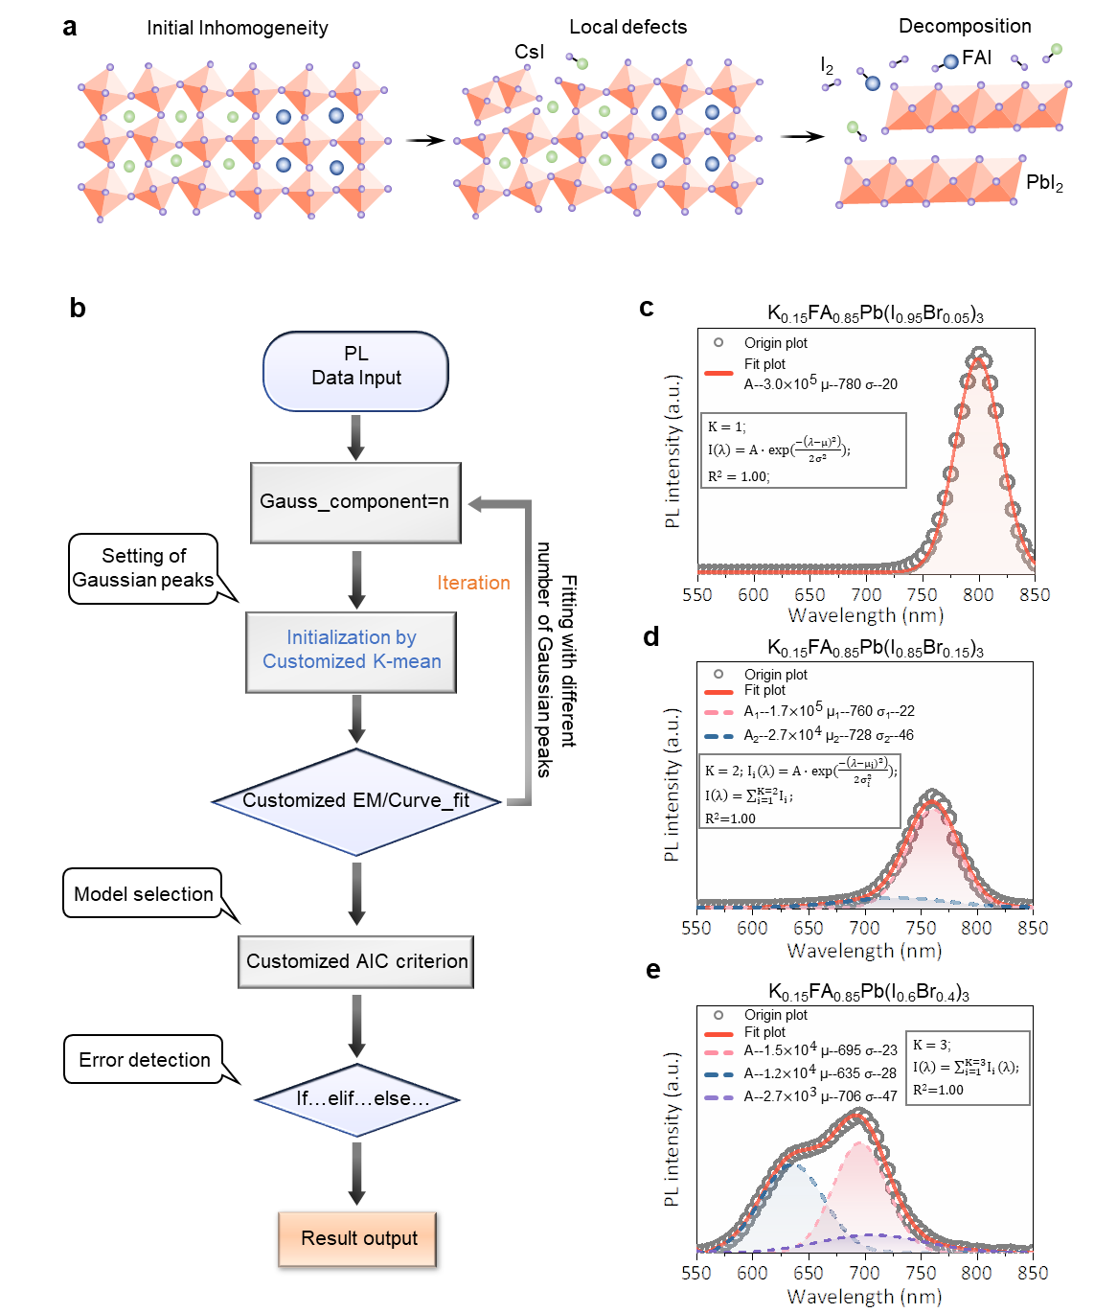
Figure 2. Illustration of intelligent feature extraction from photoluminescence spectra. (a) Schematics of the correlation between film stability and film homogeneity at their initial state. (b) The workflow of the GMM-PL algorithm, where the rectangular rectangle represents the execution step, and the diamond represents the judgment step. (c-e) The fitting results for samples with one-subpeak K_{0.15}FA_{0.85}Pb(I_{0.95}Br_{0.05})₃, double-subpeak K_{0.15}FA_{0.85}Pb(I_{0.85}Br_{0.15})₃, and muti-subpeak K_{0.15}FA_{0.85}Pb(I_{0.6}Br_{0.4})₃), respectively.
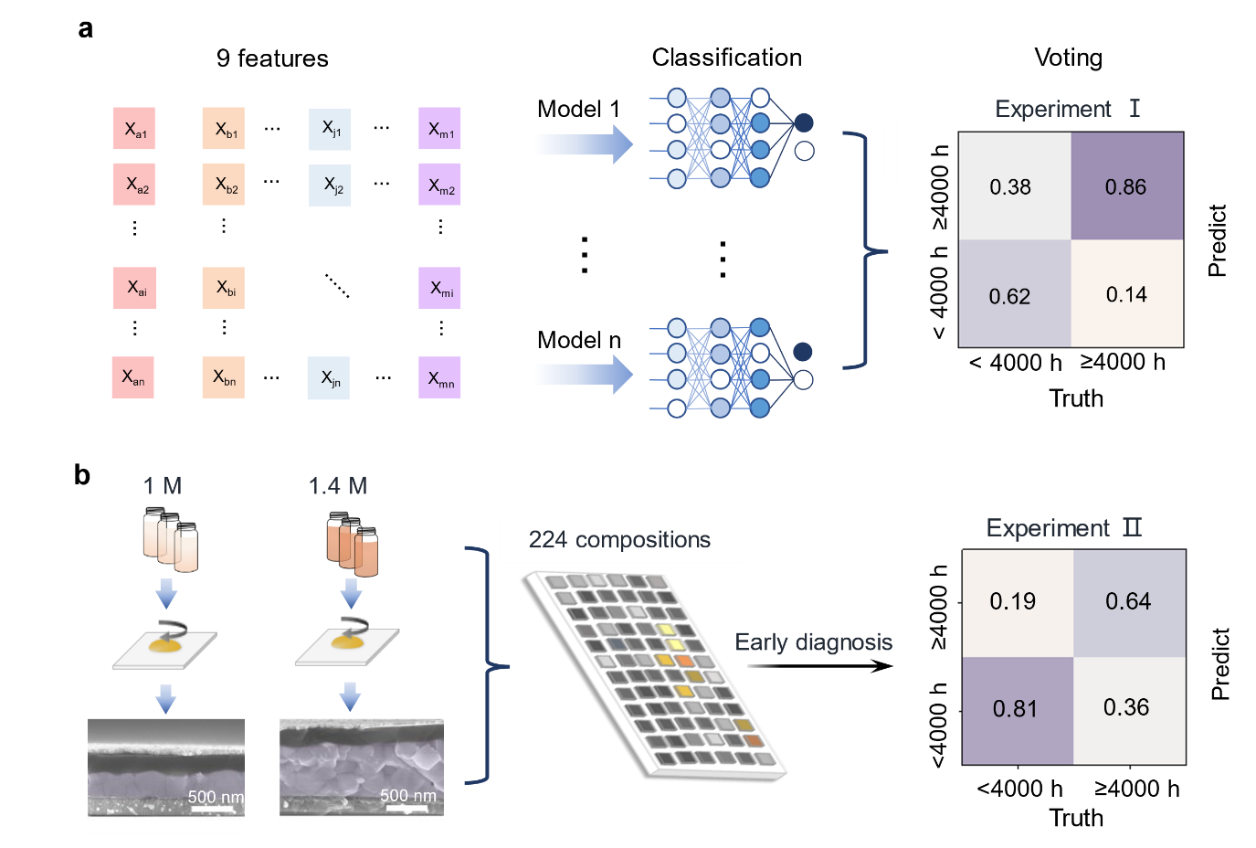
Figure 3. The integrated voting machine learning for evaluating the stability of perovskite films. (a) Schematics of the IV-ML classification model, where the confusion matrix shows the classification accuracy of Experiment I. (b) Schematics of the experimental scheme of Experiment II. The SEM image on the left side of the figure demonstrates the different thicknesses of the perovskite layer between Experiment I and II. The confusion matrix on the right side of the figure represents the classification accuracy of IV-ML for perovskite films in Experiment II.
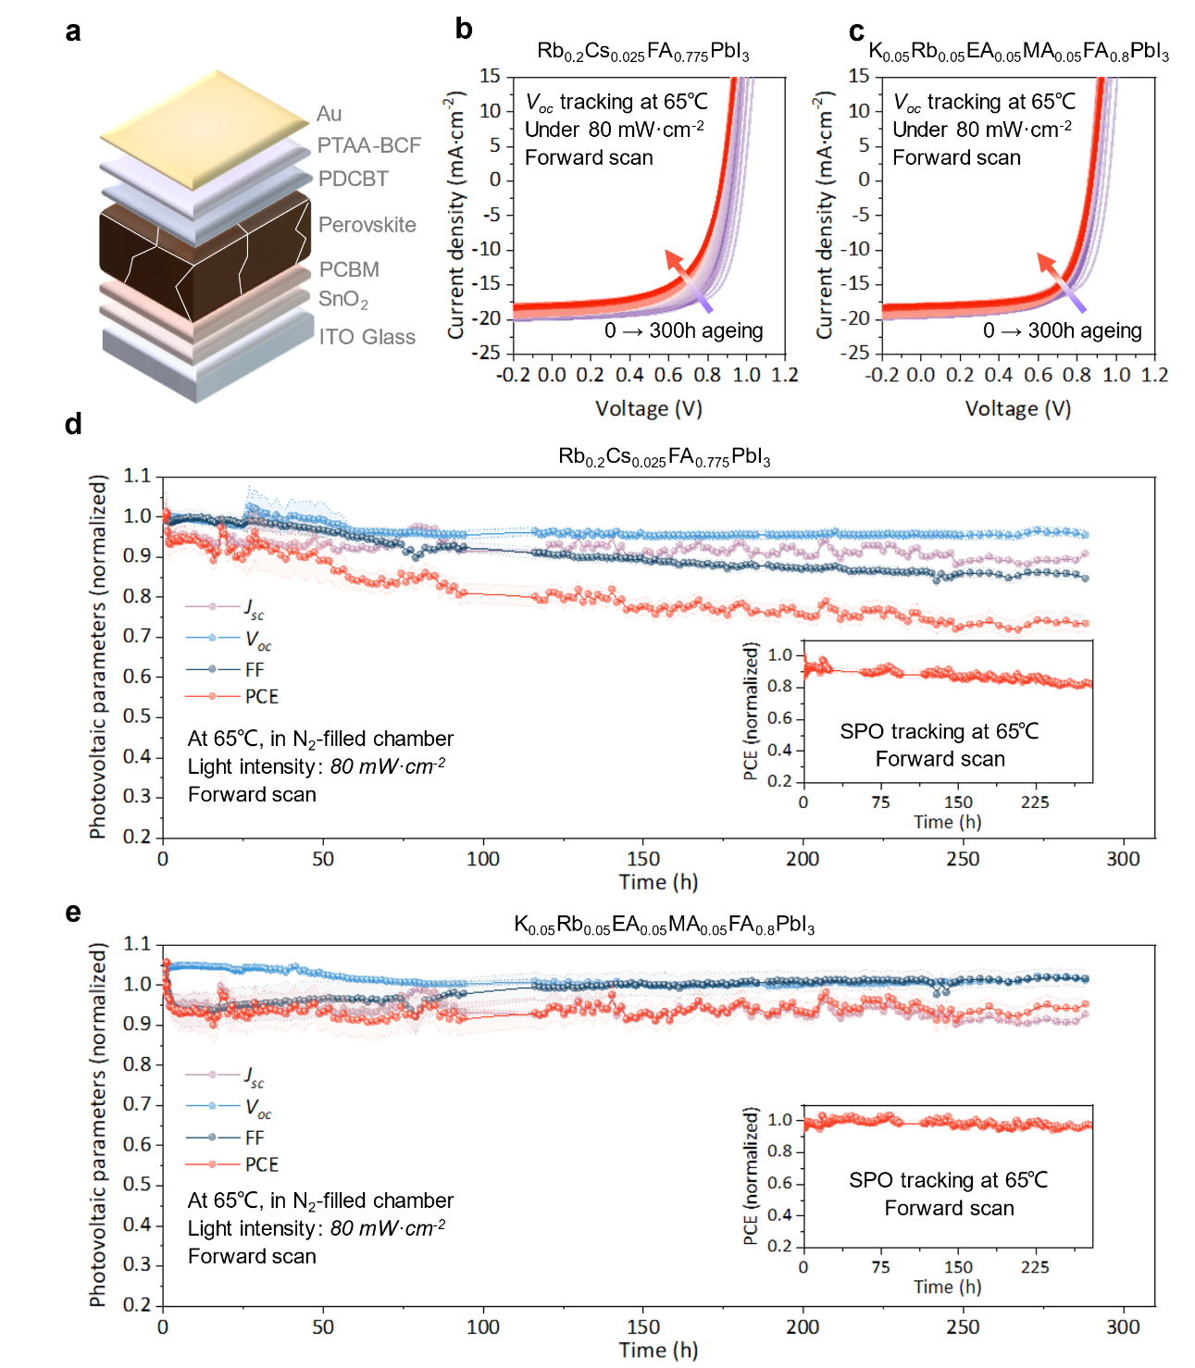
Figure 4. Stability characterizations of perovskite solar cells. (a) Schematic of the solar cell structure. (b) and (c) Time-dependent J–V curves of Rb_{0.2}Cs_{0.025}FA_{0.775}PbI₃ and K_{0.05}Rb_{0.05}EA_{0.05}MA_{0.05}FA_{0.8}PbI₃ in Experiment II, respectively. The devices are aged at 65 °C in an N₂-filled chamber and open-circuit state under metal-halide lamps from 0 h (violet) to 300 h (red). The scan direction is forward (from 0 V to 1.2 V) with a scan rate of 20 mV·s⁻¹. (d) and (e) The long-term stability of Rb_{0.2}Cs_{0.025}FA_{0.775}PbI₃ and K_{0.05}Rb_{0.05}EA_{0.05}MA_{0.05}FA_{0.8}PbI₃ in Experiment II, respectively. The unencapsulated device aged at 65 °C in N₂-filled chamber in an open-circuit state under metal-halide lamps (80 mW·cm⁻²) in the forward direction. The variation of light density is calibrated by a silicon solar cell.

Supporting Information
Details about the experimental workflow, Details about GMM-PL and intelligent Abs. analysis, machine learning models, stability characterizations.

Acknowledgment
Y. Z. acknowledges funding from the National Natural Science Foundation of China (Grant No. 52372177）

References
(1) du Fosse, I.; Mulder, J. T.; Almeida, G.; Spruit, A. G. M.; Infante, I.; Grozema, F. C.; Houtepen, A. J., Limits of Defect Tolerance in Perovskite Nanocrystals: Effect of Local Electrostatic Potential on Trap States. J. Am. Chem. Soc. 2022, 144 (25), 11059-11063.
(2) Brandt, R. E.; Poindexter, J. R.; Gorai, P.; Kurchin, R. C.; Hoye, R. L. Z.; Nienhaus, L.; Wilson, M. W. B.; Polizzotti, J. A.; Sereika, R.; Žaltauskas, R.; Lee, L. C.; MacManus-Driscoll, J. L.; Bawendi, M.; Stevanović, V.; Buonassisi, T., Searching for “Defect-Tolerant” Photovoltaic Materials: Combined Theoretical and Experimental Screening. Chem. Mater. 2017, 29 (11), 4667-4674.
(3) Kim, J. S.; Heo, J.-M.; Park, G.-S.; Woo, S.-J.; Cho, C.; Yun, H. J.; Kim, D.-H.; Park, J.; Lee, S.-C.; Park, S.-H.; Yoon, E.; Greenham, N. C.; Lee, T.-W., Ultra-bright, efficient and stable perovskite light-emitting diodes. Nature 2022, 611 (7937), 688-694.
(4) Yi, L.; Hou, B.; Zhao, H.; Liu, X., X-ray-to-visible light-field detection through pixelated colour conversion. Nature 2023, 618 (7964), 281-286.
(5) Chen, Q.; Deng, K.; Shen, Y.; Li, L., Stable one dimensional (1D)/three dimensional (3D) perovskite solar cell with an efficiency exceeding 23%. InfoMat 2022, 4 (5), e12303.
(6) Ahn, N.; Kwak, K.; Jang, M. S.; Yoon, H.; Lee, B. Y.; Lee, J. K.; Pikhitsa, P. V.; Byun, J.; Choi, M., Trapped charge-driven degradation of perovskite solar cells. Nat. Commun. 2016, 7, 13422.
(7) Fan, Z.; Xiao, H.; Wang, Y.; Zhao, Z.; Lin, Z.; Cheng, H.-C.; Lee, S.-J.; Wang, G.; Feng, Z.; Goddard, W. A.; Huang, Y.; Duan, X., Layer-by-Layer Degradation of Methylammonium Lead Tri-iodide Perovskite Microplates. Joule 2017, 1 (3), 548-562.
(8) Raval, P.; Kennard, R. M.; Vasileiadou, E. S.; Dahlman, C. J.; Spanopoulos, I.; Chabinyc, M. L.; Kanatzidis, M.; Manjunatha Reddy, G. N., Understanding Instability in Formamidinium Lead Halide Perovskites: Kinetics of Transformative Reactions at Grain and Subgrain Boundaries. ACS Energy Lett. 2022, 7 (4), 1534-1543.
(9) Zhang, C.-X.; Shen, T.; Guo, D.; Tang, L.-M.; Yang, K.; Deng, H.-X., Reviewing and understanding the stability mechanism of halide perovskite solar cells. InfoMat 2020, 2 (6), 1034-1056.
(10) Zhao, Y.; Ma, F.; Qu, Z.; Yu, S.; Shen, T.; Deng, H.-X.; Chu, X.; Peng, X.; Yuan, Y.; Zhang, X.; You, J., Inactive (PbI2)2RbCl stabilizes perovskite films for efficient solar cells. Science 2022, 377 (6605), 531-534.
(11) Tong, J.; Song, Z.; Kim, D. H.; Chen, X.; Chen, C.; Palmstrom, A. F.; Ndione, P. F.; Reese, M. O.; Dunfield, S. P.; Reid, O. G. J. S., Carrier lifetimes of> 1 μs in Sn-Pb perovskites enable efficient all-perovskite tandem solar cells. Science 2019, 364 (6439), 475-479.
(12) Dai, Z.; Yadavalli, S. K.; Chen, M.; Abbaspourtamijani, A.; Qi, Y.; Padture, N. P., Interfacial toughening with self-assembled monolayers enhances perovskite solar cell reliability. Science 2021, 372 (6542), 618-622.
(13) Azmi, R.; Ugur, E.; Seitkhan, A.; Aljamaan, F.; Subbiah, A. S.; Liu, J.; Harrison, G. T.; Nugraha, M. I.; Eswaran, M. K.; Babics, M.; Chen, Y.; Xu, F.; Allen, T. G.; Rehman, A. u.; Wang, C.-L.; Anthopoulos, T. D.; Schwingenschlögl, U.; De Bastiani, M.; Aydin, E.; De Wolf, S., Damp heat-stable perovskite solar cells with tailored-dimensionality 2D/3D heterojunctions. Science 2022, 376 (6588), 73-77.
(14) Xie, L.; Zhao, X.; Wang, J.; Li, J.; Liu, C.; Wang, S.; Bao, Q.; Yang, M.; Niu, X.; Hao, F.; Ge, Z., Multifunctional anchoring of O-ligands for high-performance and stable inverted perovskite solar cells. InfoMat 2023, 5 (2), e12379.
(15) Wang, F.; Duan, D.; Zhou, K.; Xue, Y. Z. B.; Liang, X.; Zhou, X.; Ge, C.; Zhou, C.; Xiang, J.; Zhu, J.; Zhu, Q.; Lin, H.; Shi, Y.; Chen, Y.; Li, G.; Hu, H., Ionic liquid engineering enabled in-plane orientated 1D perovskite nanorods for efficient mixed-dimensional perovskite photovoltaics. InfoMat 2023, 5 (8), e12459.
(16) Cao, Y.; Feng, J.; Xu, Z.; Zhang, L.; Lou, J.; Liu, Y.; Ren, X.; Yang, D.; Liu, S., Bifunctional trifluorophenylacetic acid additive for stable and highly efficient flexible perovskite solar cell. InfoMat 2023, 5 (10), e12423.
(17) Turren-Cruz, S.-H.; Hagfeldt, A.; Saliba, M. J. S., Methylammonium-free, high-performance, and stable perovskite solar cells on a planar architecture. Science 2018, 362 (6413), 449-453.
(18) Wang, Z.; Zeng, L.; Zhu, T.; Chen, H.; Chen, B.; Kubicki, D. J.; Balvanz, A.; Li, C.; Maxwell, A.; Ugur, E.; Dos Reis, R.; Cheng, M.; Yang, G.; Subedi, B.; Luo, D.; Hu, J.; Wang, J.; Teale, S.; Mahesh, S.; Wang, S.; Hu, S.; Jung, E. D.; Wei, M.; Park, S. M.; Grater, L.; Aydin, E.; Song, Z.; Podraza, N. J.; Lu, Z. H.; Huang, J.; Dravid, V. P.; De Wolf, S.; Yan, Y.; Gratzel, M.; Kanatzidis, M. G.; Sargent, E. H., Suppressed phase segregation for triple-junction perovskite solar cells. Nature 2023, 618 (7963), 74-79.
(19) Zhang, J.; Langner, S.; Wu, J.; Kupfer, C.; Lüer, L.; Meng, W.; Zhao, B.; Liu, C.; Daum, M.; Osvet, A.; Li, N.; Halik, M.; Stubhan, T.; Zhao, Y.; Hauch, J. A.; Brabec, C. J., Intercalating-Organic-Cation-Induced Stability Bowing in Quasi-2D Metal-Halide Perovskites. ACS Energy Lett. 2022, 7 (1), 70-77.
(20) Hartono, N. T. P.; Thapa, J.; Tiihonen, A.; Oviedo, F.; Batali, C.; Yoo, J. J.; Liu, Z.; Li, R.; Marron, D. F.; Bawendi, M. G.; Buonassisi, T.; Sun, S., How machine learning can help select capping layers to suppress perovskite degradation. Nat. Commun. 2020, 11 (1), 4172.
(21) Chakraborty, S.; Xie, W.; Mathews, N.; Sherburne, M.; Ahuja, R.; Asta, M.; Mhaisalkar, S. G., Rational Design: A High-Throughput Computational Screening and Experimental Validation Methodology for Lead-Free and Emergent Hybrid Perovskites. ACS Energy Lett. 2017, 2 (4), 837-845.
(22) Li, Y.; Yang, K., High-throughput computational design of organic–inorganic hybrid halide semiconductors beyond perovskites for optoelectronics. Energy & Environmental Science 2019, 12 (7), 2233-2243.
(23) Bartel, C. J.; Sutton, C.; Goldsmith, B. R.; Ouyang, R.; Musgrave, C. B.; Ghiringhelli, L. M.; Scheffler, M., New tolerance factor to predict the stability of perovskite oxides and halides. Sci. Adv. 2019, 5 (2), eaav0693.
(24) Ahmadi, M.; Ziatdinov, M.; Zhou, Y.; Lass, E. A.; Kalinin, S. V., Machine learning for high-throughput experimental exploration of metal halide perovskites. Joule 2021, 5 (11), 2797-2822.
(25) Liu, Z.; Rolston, N.; Flick, A. C.; Colburn, T. W.; Ren, Z.; Dauskardt, R. H.; Buonassisi, T., Machine learning with knowledge constraints for process optimization of open-air perovskite solar cell manufacturing. Joule 2022, 6 (4), 834-849.
(26) Sun, S.; Hartono, N. T. P.; Ren, Z. D.; Oviedo, F.; Buscemi, A. M.; Layurova, M.; Chen, D. X.; Ogunfunmi, T.; Thapa, J.; Ramasamy, S.; Settens, C.; DeCost, B. L.; Kusne, A. G.; Liu, Z.; Tian, S. I. P.; Peters, I. M.; Correa-Baena, J.-P.; Buonassisi, T., Accelerated Development of Perovskite-Inspired Materials via High-Throughput Synthesis and Machine-Learning Diagnosis. Joule 2019, 3 (6), 1437-1451.
(27) Sun, S.; Tiihonen, A.; Oviedo, F.; Liu, Z.; Thapa, J.; Zhao, Y.; Hartono, N. T. P.; Goyal, A.; Heumueller, T.; Batali, C.; Encinas, A.; Yoo, J. J.; Li, R.; Ren, Z.; Peters, I. M.; Brabec, C. J.; Bawendi, M. G.; Stevanovic, V.; Fisher, J.; Buonassisi, T., A data fusion approach to optimize compositional stability of halide perovskites. Matter 2021, 4 (4), 1305-1322.
(28) Zhao, Y.; Heumueller, T.; Zhang, J.; Luo, J.; Kasian, O.; Langner, S.; Kupfer, C.; Liu, B.; Zhong, Y.; Elia, J.; Osvet, A.; Wu, J.; Liu, C.; Wan, Z.; Jia, C.; Li, N.; Hauch, J.; Brabec, C. J., A bilayer conducting polymer structure for planar perovskite solar cells with over 1,400 hours operational stability at elevated temperatures. Nat. Energy 2021, 7 (1), 144–152.
(29) Zhao, Y.; Zhang, J.; Xu, Z.; Sun, S.; Langner, S.; Hartono, N. T. P.; Heumueller, T.; Hou, Y.; Elia, J.; Li, N.; Matt, G. J.; Du, X.; Meng, W.; Osvet, A.; Zhang, K.; Stubhan, T.; Feng, Y.; Hauch, J.; Sargent, E. H.; Buonassisi, T.; Brabec, C. J., Discovery of temperature-induced stability reversal in perovskites using high-throughput robotic learning. Nat. Commun. 2021, 12 (1), 2191.
(30) Zhang, J.; Wu, J.; Zhao, Y.; Zou, Y.; Barabash, A.; Wu, Z.; Zhang, K.; Deng, C.; Elia, J.; Li, C.; Rocha-Ortiz, J. S.; Liu, C.; Saboor, A.; Peters, I. M.; Hauch, J. A.; Brabec, C. J., Revealing the Crystallization and Thermal-Induced Phase Evolution in Aromatic-Based Quasi-2D Perovskites Using a Robot-Based Platform. ACS Energy Lett. 2023, 8 (8), 3595-3603.
(31) Bai, Y.; Huang, Z.; Zhang, X.; Lu, J.; Niu, X.; He, Z.; Zhu, C.; Xiao, M.; Song, Q.; Wei, X.; Wang, C.; Cui, Z.; Dou, J.; Chen, Y.; Pei, F.; Zai, H.; Wang, W.; Song, T.; An, P.; Zhang, J.; Dong, J.; Li, Y.; Shi, J.; Jin, H.; Chen, P.; Sun, Y.; Li, Y.; Chen, H.; Wei, Z.; Zhou, H.; Chen, Q., Initializing film homogeneity to retard phase segregation for stable perovskite solar cells. Science 2022, 378 (6621), 747-754.
(32) Macpherson, S.; Doherty, T. A. S.; Winchester, A. J.; Kosar, S.; Johnstone, D. N.; Chiang, Y. H.; Galkowski, K.; Anaya, M.; Frohna, K.; Iqbal, A. N.; Nagane, S.; Roose, B.; Andaji-Garmaroudi, Z.; Orr, K. W. P.; Parker, J. E.; Midgley, P. A.; Dani, K. M.; Stranks, S. D., Local nanoscale phase impurities are degradation sites in halide perovskites. Nature 2022, 607 (7918), 294-300.
(33) Doherty, T. A. S.; Winchester, A. J.; Macpherson, S.; Johnstone, D. N.; Pareek, V.; Tennyson, E. M.; Kosar, S.; Kosasih, F. U.; Anaya, M.; Abdi-Jalebi, M.; Andaji-Garmaroudi, Z.; Wong, E. L.; Madeo, J.; Chiang, Y. H.; Park, J. S.; Jung, Y. K.; Petoukhoff, C. E.; Divitini, G.; Man, M. K. L.; Ducati, C.; Walsh, A.; Midgley, P. A.; Dani, K. M.; Stranks, S. D., Performance-limiting nanoscale trap clusters at grain junctions in halide perovskites. Nature 2020, 580 (7803), 360-366.
(34) Higgins, K.; Ziatdinov, M.; Kalinin, S. V.; Ahmadi, M., High-Throughput Study of Antisolvents on the Stability of Multicomponent Metal Halide Perovskites through Robotics-Based Synthesis and Machine Learning Approaches. J. Am. Chem. Soc. 2021, 143 (47), 19945-19955.
(35) Gunasekaran, R. K.; Jung, J.; Yang, S. W.; Yun, J.; Yun, Y.; Vidyasagar, D.; Choi, W. C.; Lee, C.-L.; Noh, J. H.; Kim, D. H.; Lee, S., High-throughput compositional mapping of triple-cation tin–lead perovskites for high-efficiency solar cells. InfoMat 2023, 5 (4), e12393.
(36) Higgins, K.; Valleti, S. M.; Ziatdinov, M.; Kalinin, S. V.; Ahmadi, M., Chemical Robotics Enabled Exploration of Stability in Multicomponent Lead Halide Perovskites via Machine Learning. ACS Energy Lett. 2020, 5 (11), 3426-3436.
(37) Srivastava, M.; Hering, A. R.; An, Y.; Correa-Baena, J. P.; Leite, M. S., Machine Learning Enables Prediction of Halide Perovskites' Optical Behavior with >90% Accuracy. ACS Energy Lett. 2023, 8 (4), 1716-1722.
(38) Zhang, J.; Liu, B.; Liu, Z.; Wu, J.; Arnold, S.; Shi, H.; Osterrieder, T.; Hauch, J. A.; Wu, Z.; Luo, J.; Wagner, J.; Berger, C. G.; Stubhan, T.; Schmitt, F.; Zhang, K.; Sytnyk, M.; Heumueller, T.; Sutter-Fella, C. M.; Peters, I. M.; Zhao, Y.; Brabec, C. J., Optimizing Perovskite Thin-Film Parameter Spaces with Machine Learning-Guided Robotic Platform for High-Performance Perovskite Solar Cells. Adv. Energy Mater. 2023, 2302594.
(39) Mao, W.; Hall, C. R.; Bernardi, S.; Cheng, Y. B.; Widmer-Cooper, A.; Smith, T. A.; Bach, U., Light-induced reversal of ion segregation in mixed-halide perovskites. Nat. Mater. 2021, 20 (1), 55-61.
(40) Guo, D.; Bartesaghi, D.; Wei, H.; Hutter, E. M.; Huang, J.; Savenije, T. J., Photoluminescence from Radiative Surface States and Excitons in Methylammonium Lead Bromide Perovskites. J. Phys. Chem. Lett. 2017, 8 (17), 4258-4263.
(41) Correa-Baena, J.-P.; Luo, Y.; Brenner, T. M.; Snaider, J.; Sun, S.; Li, X.; Jensen, M. A.; Hartono, N. T. P.; Nienhaus, L.; Wieghold, S.; Poindexter, J. R.; Wang, S.; Meng, Y. S.; Wang, T.; Lai, B.; Holt, M. V.; Cai, Z.; Bawendi, M. G.; Huang, L.; Buonassisi, T.; Fenning, D. P., Homogenized halides and alkali cation segregation in alloyed organic-inorganic perovskites. Science 2019, 363 (6427), 627-631.
(42) Kim, M.; Kim, G.-H.; Lee, T. K.; Choi, I. W.; Choi, H. W.; Jo, Y.; Yoon, Y. J.; Kim, J. W.; Lee, J.; Huh, D.; Lee, H.; Kwak, S. K.; Kim, J. Y.; Kim, D. S., Methylammonium Chloride Induces Intermediate Phase Stabilization for Efficient Perovskite Solar Cells. Joule 2019, 3 (9), 2179-2192.
(43) Brinkmann, K. O.; Becker, T.; Zimmermann, F.; Kreusel, C.; Gahlmann, T.; Theisen, M.; Haeger, T.; Olthof, S.; Tuckmantel, C.; Gunster, M.; Maschwitz, T.; Gobelsmann, F.; Koch, C.; Hertel, D.; Caprioglio, P.; Pena-Camargo, F.; Perdigon-Toro, L.; Al-Ashouri, A.; Merten, L.; Hinderhofer, A.; Gomell, L.; Zhang, S.; Schreiber, F.; Albrecht, S.; Meerholz, K.; Neher, D.; Stolterfoht, M.; Riedl, T., Perovskite-organic tandem solar cells with indium oxide interconnect. Nature 2022, 604 (7905), 280-286.
(44) Moon, T. K., The expectation-maximization algorithm. IEEE Signal Process. Mag. 1996, 13 (6), 47-60.
(45) Polanski, A.; Marczyk, M.; Pietrowska, M.; Widlak, P.; Polanska, J., Signal Partitioning Algorithm for Highly Efficient Gaussian Mixture Modeling in Mass Spectrometry. PLoS One 2015, 10 (7), e0134256.
(46) Meng, X.-L.; Van Dyk, D., The EM Algorithm—an Old Folk-song Sung to a Fast New Tune. J. R. Stat. Soc. Series B Stat. Methodol. 1997, 59 (3), 511-567.
(47) Stoica, P.; Selen, Y., Model-order selection: a review of information criterion rules. IEEE Signal Process. Mag. 2004, 21 (4), 36-47.
(48) Lundberg, S. M.; Erion, G.; Chen, H.; DeGrave, A.; Prutkin, J. M.; Nair, B.; Katz, R.; Himmelfarb, J.; Bansal, N.; Lee, S. I., From Local Explanations to Global Understanding with Explainable AI for Trees. Nat. Mach. Intell. 2020, 2 (1), 56-67.
(49) Hu, Y.; Hutter, E. M.; Rieder, P.; Grill, I.; Hanisch, J.; Aygüler, M. F.; Hufnagel, A. G.; Handloser, M.; Bein, T.; Hartschuh, A.; Tvingstedt, K.; Dyakonov, V.; Baumann, A.; Savenije, T. J.; Petrus, M. L.; Docampo, P., Understanding the Role of Cesium and Rubidium Additives in Perovskite Solar Cells: Trap States, Charge Transport, and Recombination. Adv. Energy Mater. 2018, 8 (16), 1703057.
(50) Correa-Baena, J.-P.; Hippalgaonkar, K.; van Duren, J.; Jaffer, S.; Chandrasekhar, V. R.; Stevanovic, V.; Wadia, C.; Guha, S.; Buonassisi, T., Accelerating Materials Development via Automation, Machine Learning, and High-Performance Computing. Joule 2018, 2 (8), 1410-1420.
(51) Peña-Camargo, F.; Caprioglio, P.; Zu, F.; Gutierrez-Partida, E.; Wolff, C. M.; Brinkmann, K.; Albrecht, S.; Riedl, T.; Koch, N.; Neher, D.; Stolterfoht, M., Halide Segregation versus Interfacial Recombination in Bromide-Rich Wide-Gap Perovskite Solar Cells. ACS Energy Lett. 2020, 5 (8), 2728-2736.

